ASSIGNMENT – 2(technical presentation)

Name: K. Nagapreetham
Reg no: 192525242
Course code: csa1613
Course name: datawarehouse and dataminning

Topic 2: Operational Systems vs DSS
Operational Systems (OLTP):
- Handles daily transactions
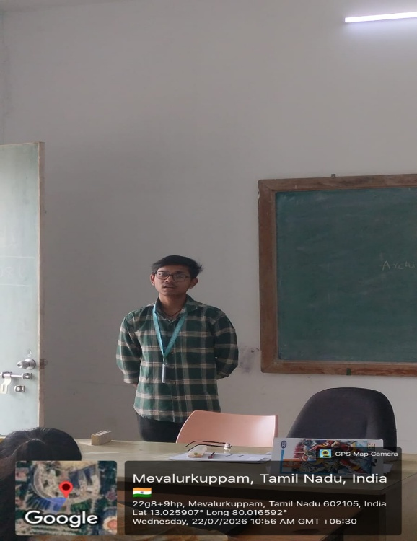
- Fast processing
- Current data
- Example:
  - ATM
  - Online shopping
DSS (OLAP):
- Supports analysis
- Historical data
- Decision making
- Forecasting

OLTP vs OLAP
OLTP | OLAP
Transaction processing | Data analysis
Current data | Historical data
Many users | Few analysts
Fast updates | Complex queries

Key Differences
- Purpose
- Users
- Data
- Speed
- Query complexity
Performance Comparison:
OLTP
- Thousands of transactions
OLAP
- Large analytical queries
- Multi-dimensional analysis
Use Cases:
OLTP
- Banking
- Hospital billing
OLAP
- Sales analysis
- Business forecasting
Integration:
- OLTP collects data
- ETL transfers data
- Data warehouse stores data
- OLAP analyzes data
Example:
Amazon
- OLTP → Customer Orders
- OLAP → Sales Analysis
Slide 10: Conclusion
Both systems are important and complement each other.

